Lesson 8: Endings

Endings are pretty much self explanatory but lets take a look at them. The standard endings are all in the Akane strip including the code for them.

function ShowEndingBoughtBack()
{
EndingBoughtBack._visible = true;
}

You shouldn't have to do anything but background colors and pictures. The text is defaulted and gives a standard ending story.

Lets look at the customer endings now. First function is NumCustomEndings... put in the number of custom endings.

function NumCustomEndings() : Number //returns number of endings... that's it
{
return 2;
}

The if statement here sets the conditions required for the ending to be displayed, else returns false. Hides all pictures, sets the ending number, puts up a picture and then sends to EndingFinish.

function EndingStart(total:Number) : Boolean
{
if (true) // insert the conditions to get the ending
{
_root.HideImages();//hide pictures
_root.HidePlaces();
_root.HideEndings();
_root.NumFin = 30; //first non standard ending
ArenaMenaceBattle1._visible = true; //show your picture
}
else if (true) // insert the conditions to get the ending
{
_root.HideImages();//hide pictures
_root.HidePlaces();
_root.HideEndings();
_root.NumFin = 31; //second non standard ending
ArenaMenaceBattle2._visible = true; //show your picture
}
return false;
}

This function adds the flavor text to the ending and the total score. NumFin = 1000 tell the Slave Maker that it was the final ending and end the game.

function EndingFinish(total:Number) : Boolean
{
if (_root.NumFin == 30)
{
_root.SetText("Flavor Text about the ending");
_root.AddText("\r\rArena Gladiator'\r\rScore : " + total); //final ending statement with //total score
_root.NumFin = 31; //loop to next ending
return true;
}
if (_root.NumFin == 31)
{
_root.SetText("Flavor Text about the ending");
_root.AddText("\r\rSuper Gladiator'\r\rScore : " + total); //final ending statement with //total score
_root.NumFin = 1000; //no more endings
return true;
}
return false;
}
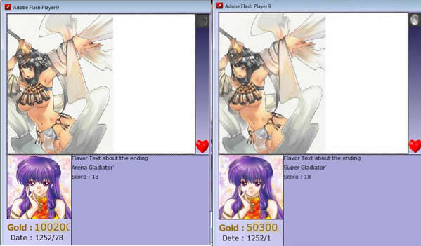

The last part here is the hint text that tells the player how to get one of the special endings. Just change the Text add extra cases or remove depending on endings.

function ShowEndings(ending:Number)
{
switch (ending) {
case 0:
_root.SetText("How to get ending 30");
break;
case 1:
_root.SetText("How to get ending 31");
break;
}
}
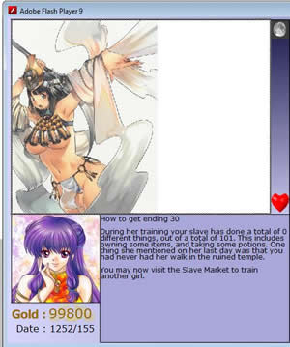

Not that exciting you can pretty much just copy over the examples in Akane. If you have made it this far, the endings are the easy part.

Lesson 9: House Exploration

